Title (Font size 14)
First author¹, Second author², ………… (Font size 12)
¹ Affiliated Institution
² Affiliated Institution
*Corresponding author: Name (email address)
[Date of Submission: Date of Acceptance: (Used for Conference Organizing Team only)]
Abstract (Font size 12)
[Abstract should be finished between 200-250 words in a single paragraph. This section should not contain any table or figure.] (Font size 11)
Keywords: (at least 5 keywords, maximum 7) e.g., GeoMundus; Geospatial; Intelligence; Sustainability
1 Introduction
[These days, the whole world is experiencing a wide range of climate-induced challenges resulting in huge losses and damages (Acosta et al., 2016). With a view to reducing losses and damages, sustainable environmental management is crucial (Boda et al., 2021). …………………….] (Font size 11)
2 Study Area
3 Methodology
3.1 Sub-section of methodology (Font size 12)
3.2 Subsection of methodology……………
[The following Eq. 1 is used for calculating the Normalized Difference Vegetation Index (NDVI) followed by Nomura and Oki (2021).
…………………………………………………………………………………. (1)
Where NIR means near-infrared spectrum and RED indicates the red range of the spectrum.] (Font size 11)
4 Results
[Figure 1 shows the logo of the 15th GeoMundus Conference that will be held in Castellon de la Plana, Spain on 20-21 October 2023. Table 1 illustrates some agenda of the conference.] (Font size 11)
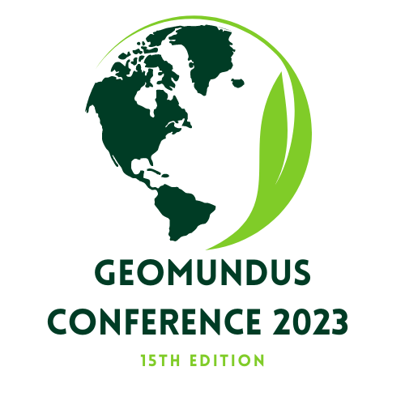
Figure 1: Logo of the 15th GeoMundus Conference (Font size 10)

Table 1: Some of the conference agenda (Font size 10)
SL | Agenda | Date
1 | City tour | 19th of October
2 | Opening Ceremony | 20th of October
3 | Workshop | 21st of October
Note: The full schedule is available on the website [Footnote; font size 9 and Italic]
4.1 Sub-section of results (if needed)
4.2 Sub-section of results (if needed) ……………
5 Discussion
6 Conclusion
Acknowledgment
References
Acosta, L. A., Eugenio, E. A., Macandog, P. B. M., Magcale-Macandog, D. B., Lin, E. K. H., Abucay, E. R., ... & Primavera, M. G. (2016). Loss and damage from typhoon-induced floods and landslides in the Philippines: community perceptions on climate impacts and adaptation options. International Journal of Global Warming, 9(1), 33-65.
Boda, C. S., Faran, T., Scown, M., Dorkenoo, K., Chaffin, B. C., Nastar, M., & Boyd, E. (2021). Loss and damage from climate change and implicit assumptions of sustainable development. Climatic Change, 164, 1-18.
Nomura, R., & Oki, K. (2021). Downscaling of MODIS NDVI by using a convolutional neural network-based model with higher resolution SAR data. Remote Sensing, 13(4), 732.

General instructions:
- The font style for the whole manuscript should be “Times New Roman”
- If it is necessary to use an abbreviation, please mention the full form of the abbreviation (e.g., NDVI - sub-section 3.2).
- Bullet points should be avoided in the manuscript.
- The font size of the manuscript’s title is 14.
- The font size of all headings is 12.
- The font size of the content under all headings is 11 (except for figure and table)
- The font size of the figures caption is 10 (Figure 1).
- The font size of the content and the caption of the tables is 10 (Table 1).
- The font size of the footnote is 9 and the style is Italic (Footnote of Table 1).

Please do not change the style of the template and follow the instructions!

